I proclaim myself to be Hash Stud of the Year. Why do you ask? Well for my most hashalicious Minibike Hash, I was hare, cook, first-aid attendant, scribe and hash flash.
Hash # 1556
Hare: Beaver Muncher
Location: Beaver’s
Hounds: Loogy, Anal, Twatever, Just Quinn, Just Anya, Rat Bastard, YAAC, Just Douglass, Just Jonathon, Miscast, Hazmat, Ped-o-File, Platty, Idol Snatch, Milf And Cookies, Yes Eye Wood, Mr up, GI, I Like Head, Breaststoke, Tickets, Pussy Destroyer, Jersey A$$hole, Just Diane, Tubby, Hasher with Five toe shoes.
Preliminaries: Jersey was the first to show and had a few laps around the block on the beasty bikes. Followed by Loogy, Rat, Mr Up, Tickets and a few others. Then things went Bad, Very Bad. Here’s those inept instructors giving Yes Eye Wood here fatefull instructions:
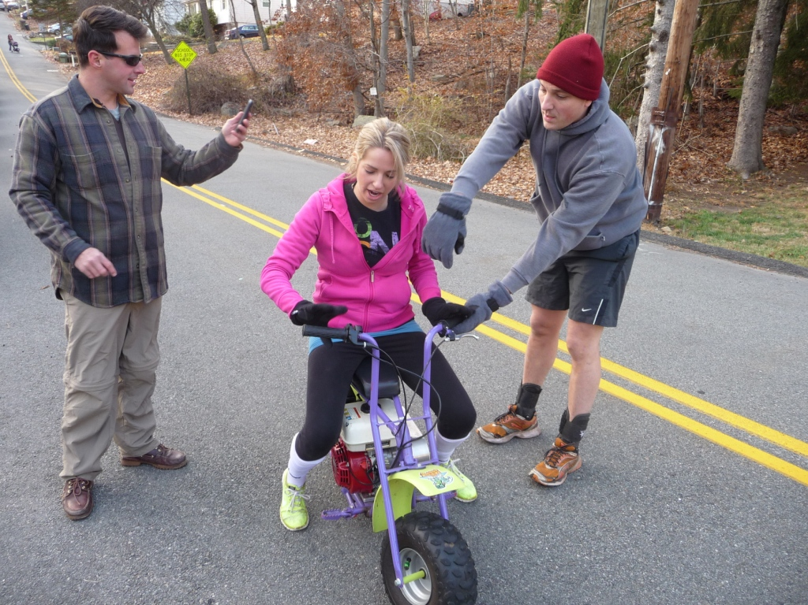
Ten seconds later she’s on the ground yelling for help. I then abanded my role as hashflash, and ran over to help the damsel in distress. So no photos of the fallen princess. Thank heavens that it was not more serious than very bad scrape. After bandaging her up, I quickly gathered the hounds and sent them on their way with the simple words “follow the dots”. After all, they are all pros.
I have no idea if the trail was really awesome or not, but it was beautifully set.
Yes Eye Wood then joined me to go to the Beer Check, where about 2/3 of the pack made it. The others choose to short cut.
Circle: Arranged in driveway surrounding the firepit. Fire courageously started by Loogey, Jersey and others.
DownDowns
Hare of Course,
FRB: Anal
DFL: Tubby?
Non Runners: Milf, Just Diane, YAAC.
Accusations of note:
Yes Eye Wood: for being the first MiniBike HashCrash
Tickets: for hanging on Van riding down the street.
Accusation not Given: To Beaver for not getting out of circle early enough to get the food prepared.
Food offerings were Curry Chicken, spicy Lentils, basmati rice, and Baked Ziti.
A HUGE shout out to Milf and Cookies, Just Diane and Twat for helping me out in the kitchen, both getting the food hot and cleaning up. You’re the best.
Thanks to Tickets for telling me I’m number one!
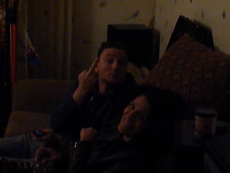
And a very special thanks to Loogey, who kept the fire going all night and for also holding his own private Special Edition Mini Circles outside.
You are all the BEST. Thanks for a great day! I wish I remembered more but there was Beer!

Beaver Muchcer,

