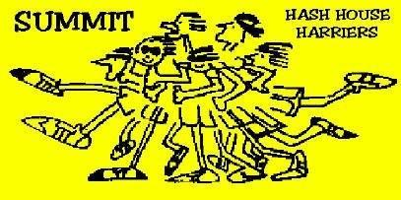

LABOR DAY Monday, Sept 1, 2014
Summit Hash #1610
Start: South Mountain Dog Park, special time 3pm
Laborious, labor intensive, labrador; none of these words described the enthusiasm of the pack on this hot and humid moday afternoon. The early pack arrived to the dog park amidst mall style parking, where you had to walk far just to get to where you want to go. it seems that other members of our community had decided to bombard the park with a thousand person party, including a DJ, grilling and twerking; but they were dressed in their sunday funday finest and in comparison to their party, the hash was small peanuts for the cops. Thank god there arent more holidays where they are allowed to disturb the peace. All that was no matter because Seoul Brudda had come back from Indyscent!, so who cares about them, lets move on to trail.
Our wonderful Ex-GM Hare Loogie thought nothing of the late summer heat and set a dead r*n trail. x# of miles started out by heading west from the dog park and then turning south at the second check (of which there were only 3?) before the pack was covered in sweat and started walking. a few harrierets were so saturated at this point that they could have used a wring out of the t-shirt, but Tickets kept his composure and waited until the beer check to impose himself. At the assumed check just over the bridge, Nut in my hair asserted himself and led a good portion of the pack ashtray, toward the upper trail, rather than the lower trail that followed the waters edge. If you dont believe me, NIMH tape recorded most of trail and should be submitting a highlight reel to hashflash soon. No Gen was the smartest(?) hasher here and followed flour and led the regrouping of the pack. At this point, aside from the heat, trail was utterly delightful. the pack was given a chance to view the work of a very generous artist in the form of graffiti on the side of the building close to the new dam. Just beyond we passed a few families bathing with and with their dogs. Suprisingly or unsuprisingly, trail led to beer at the picnic pavilion with the cold water spring just behing the library/train station/EMS. Good Beer was had by all. Pedal left a very sweaty muscular impression of his buttocks on a picnic table next to Son of Seoul and claimed the seat as his own. Foreskin absconded a bag of chips and sat aside like a wallflower with his son and talked about baseball. AutoErotica helped FlipFlop to the ecoli infected spring water. Trail begrudgingly led up the hill to Crest Road where all but Jersey and Dunk-in-Hinds (LVH3 visitor) decided to take the road back to the cars. it was about x distance on either path. Everyone arrived together and circle was started quickly. Tickets was Beer Bitch, the accusations will follow and then all but few went to Bunnys where the food was poor and the beer was cheap.
Submitted by: Jersey Asshole

