Silverlight SharePoint Picture Library Viewer Web Part
Author: Rod Stagg, SharePoint Guru L.L.C. http://rstagg.com
02/23/2010
Download and configuration instructions:
Download Silverlight application files:
- Filmstrip.xap
- PictureFilmstripTestPage.html
Locate and existing document library or create a new document library to store the Silverlight application files. Ten create a new folder in your document library and name it ClientBin.
SharePoint 2010
Upload the Filmstrip.xap file to any document library in your SharePoint 2010 site.
Make a note of the Filmstrip.xap URL (right-click, copy short etc.)
Locate an existing picture library on your SharePoint or create a new Picture Library from the View All Site Content selection under Site Actions.
Select the picture library list settings selection and locate the listid in the URL. Copy the listid from the URL to use in the PictureFilmstripTestPage.html. The format of the list id is in the form listid=%7B62C70743%2D3D19%2D466C%2DADBF%2D03F208C24768%7D
Navigate to the SharePoint site page where you would like to display the picture banner, add the new Silverlight web-part to the page. Use the Filmstrip.xap file URL for the requested URL. In the other settings section input the siteurl and listurl in Custom Initialization Parameters web-part settings form.

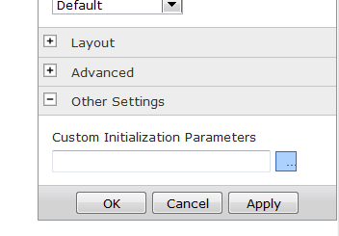
Example Setting as input to Custom Intialization Parameters. siteurl=http://rstaggvpc01/ratings,listid=%7B62C70743%2D3D19%2D466C%2DADBF%2D03F208C24768%7D,viewid=%7B7B1E6804%2D53B4%2D41AE%2D93F7%2D5E5737BAC489%7D"
SharePoint 2007
Configuring the PictureFilmstripTestPage.html for your picture library.
This is the tricky part.
Locate an existing picture library on your SharePoint or create a new Picture Library from the View All Site Content selection under Site Actions.
Select the picture library list settings selection and locate the listid in the URL. Copy the listid from the URL to use in the PictureFilmstripTestPage.html. The format of the list id is in the form listid=%7B62C70743%2D3D19%2D466C%2DADBF%2D03F208C24768%7D
Open the PictureFilmStripTestPage.html in SharePoint Designer, Notepad, or any valid web-page or text editor and locate the siteurl and listid settings. Copy and replace the existing siteurl and listid values with your SharePoints base URL and your picture library’s listid (copied from step above)
<div id="silverlightControlHost">
<object data="data:application/x-silverlight-2," type="application/x-silverlight-2" width="650" height="110">
<param name="source" value="ClientBin/FilmStrip.xap"/>
<param name="onerror" value="onSilverlightError" />
<param name="background" value="white" />
<param name="minRuntimeVersion" value="2.0.31005.0" />
<param name="initParams" value="siteurl=http://rstaggvpc01/ratings,listid=%7B62C70743%2D3D19%2D466C%2DADBF%2D03F208C24768%7D,viewid=%7B7B1E6804%2D53B4%2D41AE%2D93F7%2D5E5737BAC489%7D" />
<param name="autoUpgrade" value="true" />
<a href="http://go.microsoft.com/fwlink/?LinkID=124807" style="text-decoration: none;">
<img src="http://go.microsoft.com/fwlink/?LinkId=108181" alt="Get Microsoft Silverlight" style="border-style: none"/>
</a>
</object>
<iframe style='visibility:hidden;height:0;width:0;border:0px;' scrolling=no></iframe>
</div>
Save changes.
Upload Silverlight files to your document library:
- Filmstrip.xap (Upload into ClientBin folder created above i.e. MyDocumentLibrary/ClientBin/Filmstrip.xap)
- Your modified PictureFilmstripTestPage.html (Upload directly into the root level of the document library above i.e. MyDocumentLibrary/PictureFilmstripTestPage.html
- Test the PictureFilmstripTestPage.html page to make sure you configured properly by simply clicking the link in the document library.
Displaying on a SharePoint 2007 site page
Locate the site page where you would like to display the banner as a webpart.
From site actions select edit page.
Add a content editor web-part to a web part zone.
Modify the content editor web-part, choose source and add the reference to the Silverlight web application files. (Once configured you can export this web part to your desktop and import onto any site page, even on other SharePoint sites)
<iframe src=”[URL of your PictureFilmstripTestPage.html page goes here]” height=”110” width=”650” frameboder=”0” scrolling=”no”></iframe>
Save the webpart and the banner is displayed on the page.

Common reported issues:
Error when banner loads-one or more images from picture library not displaying in banner
Probable Cause: The Silverlight SharePoint Picture Library Viewer Web Part is not configured to display folders in picture libraries-only images.
Resolution: Either disable the folders in the picture libraries default view (if acceptable for your scenario) or create a new view in the picture library, disable folders, and note the viewid of the view and designate as the viewid in the PictureFilmStripTestPage.html.

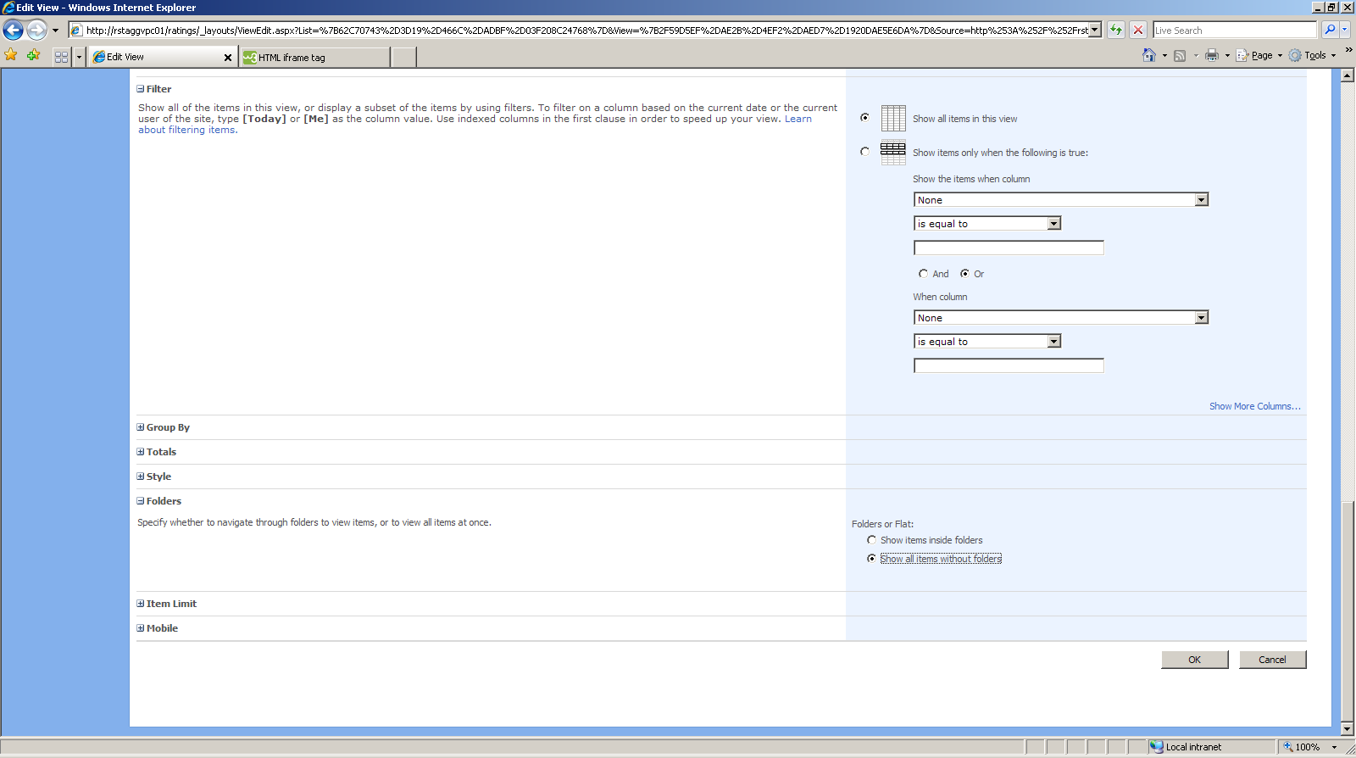

The banner is not displaying any images:
Probable Causes
- Either the listid or siteurl is incorrect in the PictureFilmStripTestPage.html.
- The FilmStrip.xap file is not located in a location accessible by the PictureFilmStripTestPage.html file.
- The URL to the PictureFilmStripTestPage.html is incorrect in the content editor webpart.

