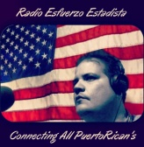

Radio Esfuerzo EstadiastaTv.

Al pueblo estadista...

La lucha del pueblo puertorriqueño por alcanzar la estadidad ha tenido muchos frentes, desde plebiscitos, manifestaciones multitudinarias tanto en Washington como en la isla, cabildeo, reuniones en Washington, apoyo y alianzas con gobernadores de otros estados, representantes, senadores y hasta presidentes de ambos partidos nacionales.

Pero eso no ha sido suficiente.

Todos sabemos que los que se oponen a la estadidad y defienden la colonia están haciendo todo lo posible para obstruir el camino y torpedear los resultados del plebiscito de noviembre de 2012. Estas acciones van en contra los derechos de la mayoría que decidió revocarle el consentimiento al estatus actual y escogió la estadidad sobre las demás alternativas.

Este pasado plebiscito fue legítimo, de acuerdo a los parámetros e instrucciones del informe del Task Force" de Casa Blanca que fue refrendado con la firma del Presidente Barack Obama, contrario a lo que han dicho los líderes del Partido Popular Democrático junto a los líderes de los otros partidos y que la prensa local ha publicado.

Ha llegado la hora de que el pueblo estadista se haga sentir. Debemos dejarle saber al pueblo americano y a los miembros del Congreso, que tienen autoridad plena sobre nosotros, nuestro deseo de lograr la Igualad plena para los ciudadanos americanos que viven el en isla.

Un grupo de ciudadanos comprometidos con esta lucha se han dado a la tarea de recopilar información muy importante para que los estadistas tengamos argumentos de peso para exigir el derecho a la igualdad que todo ciudadano estadounidense tiene y defiende, los puertorriqueños no somos la excepción.

La información que se incluye contiene:
- los nombres de los senadores con su información para contactarlos.

- links de portales para conocer la historia de cada estado, como fue su lucha para entrar a la unión

- Papeletas con la pregunta SI/NO de admisión de los estados De Hawaii Y Alaska .

- Un listado de soldados puertorriqueños con una breve reseña y sus enlaces, Con su rol en la Fuerzas Armadas de los Estados Unidos en la net —
Esta información ha sido recopilada por Antonio “Tony El Marín” Santiago,.

- Modelos de cartas sugeridos por el Dr. Hernán Padilla. Y de el grupo de Igualdad.

Es imperativo que los que creemos en la estadidad llevemos un plan organizado para comunicarnos con los miembros del Senado y así informarles que nuestra lucha es legítima, es la misma que los demás estados, que han ingresado a la unión tuvieron en su momento y además, la razón principal es convencerlos de que apoyen el Proyecto S. 2020 sometido por los demócratas Martin Heinrich (Nuevo México) y Ron Wyden (Oregón).

Este esfuerzo consiste en escribirles a los senadores por medio de cartas por correo, emails o algún otro tipo de mensajes para dejarles saber nuestro sentir y pedirle apoyo a nuestra petición. Todo se hará de manera escalonada, por estado, para ayudar al Comisionado Residente en Washington, Pedro Pierluisi, a combatir la desinformación de otras agrupaciones, noticias de la prensa y hasta cabilderos pagados con fondos públicos del pueblo de Puerto Rico.

No hay mejor información que la que ellos recibirán del pueblo puertorriqueño directamente.

¡Únete estadista,
Contamos contigo!

==========================================================================================================================
Comenzamos con el Estado Alabama
En los próximos día usted debe contactar”
A
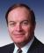
Shelby, Richard Republican
Senior Senator from Alabama, 1987-2017
Representative, Alabama's 7th District

Washington D.C.
304 Russell Senate Office Building
Washington, DC 20510
Telephone: (202) 224-5744
Fax: (202) 224-3416

Official Web page : http://www.shelby.senate.gov

Twitter : @SenShelbyPress

Facebook : https://www.facebook.com/RichardShelby

B
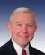
Sessions, Jefferson “Jeff” Republican
Junior Senator from Alabama, 1997-2015
Washington D.C.
326 Russell Senate Office Building
Washington, DC 20510
Main: (202) 224-4124
Fax: (202) 224-3149

Official Web page http://www.sessions.senate.gov
Twitter : @SenatorSessions

Facebook: https://www.facebook.com/jeffsessions?rf

=============================================================

Trasfondo Histórico del estado de Alabama. (Recomendamos leer de ¿Cómo el estado entró a la Unión? ) Link http://pt.wikipedia.org/wiki/Alabama

=============================================================
-Ballot – Ballot –
Alaska Admission as a State – Hawaii Admission as a State –
August 26, 1958 June 27, 1959

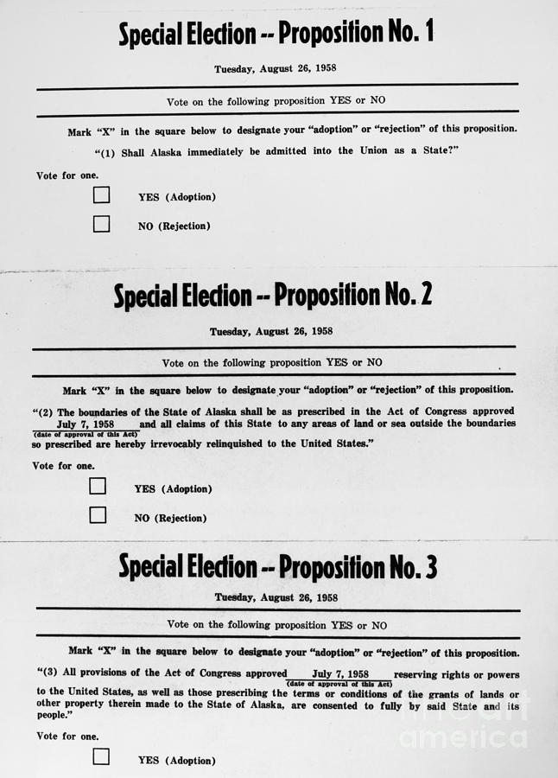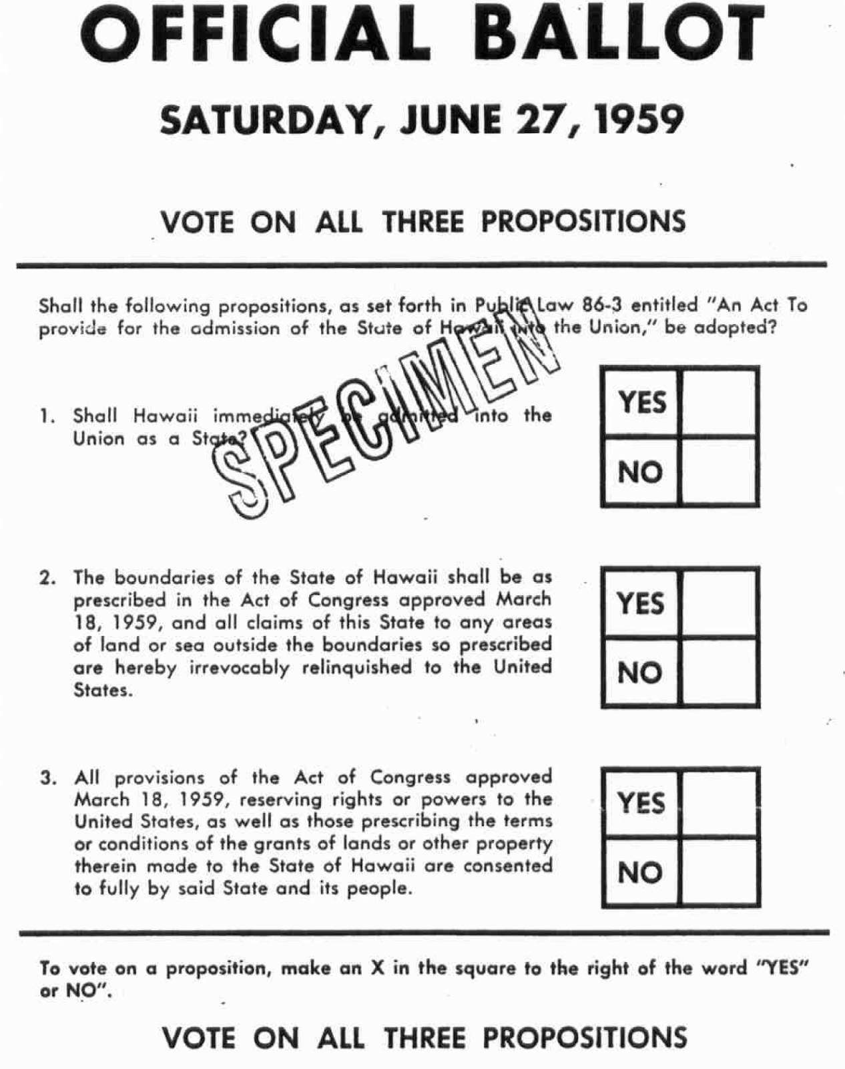

Se pide la aprobación del S2020 como parte del proceso y el derecho a entrar a la Unión en Igualdad de Condición como los demás estados, ante la pregunta SI /NO
==========================================================================================================================

Ciudadanos AMERICANOS procedentes de la isla de Puerto Rico que han servido en las fuerzas armadas, y sus links ( los link están en inglés escritos precisamente por un veterno-Tony el Marien Santiago -
1)Humberto Acosta-Rosario, (January 15, 1947 – August 22, 1968) Staff Sergeant, U.S. Army - Acosta-Rosario was a member of Company B, 1st Battalion, 5th Infantry (Mechanized); 25th Infantry Division, United States Army. He is currently the only Puerto Rican Missing In Action whose body has never been recovered.
https://en.wikipedia.org/wiki/Humberto_Acosta-Rosario

- 2)Ricardo Aponte, (born c. 1949) Brigadier General, U.S. Air Force -ponte is the former Director of the Innovation and Experimentation Directorate, United States Southern Command, the first Puerto Rican to hold said position.
https://en.wikipedia.org/wiki/Ricardo_Aponte

- 3)Félix Arenas Gaspar, (December 13, 1891 – July 29, 1921) Captain, Spanish Army - Arenas Gapar was posthumously awarded the Cruz Laureada de San Fernando (Spain's version of the Medal of Honor) for his actions in the Rif War.
https://en.wikipedia.org/wiki/F%C3%A9lix_Arenas_Gaspar

- 4)Domingo Arroyo, Jr., (March 7, 1971 – January 13, 1993), Private First Class, U.S. Marine Corps - Arroyo was the first Puerto Rican and American serviceman to be killed in Operation Restore Hope during the Somalian Civil War.
https://en.wikipedia.org/wiki/Domingo_Arroyo,_Jr.

- 5)Joseph (José) B. Aviles, Sr., (February 3, 1897 - February 22, 1990) CWO2, U.S. Coast Guard - On September 28, 1925, Aviles became the first Hispanic Chief Petty Officer in the United States Coast Guard. During World War II he received a war-time promotion to Chief Warrant Officer, becoming the first Hispanic to reach that level as well.
https://en.wikipedia.org/wiki/Joseph_B._Aviles,_Sr.

6)Rafael Celestino Benítez, (March 9, 1917 – March 6, 1999) Rear Admiral, U.S. Navy - Benítez was a highly decorated submarine commander who led the rescue effort of the crew members of the USS Cochino which was involved in the first American undersea spy mission of the Cold War.
https://en.wikipedia.org/wiki/Rafael_Celestino_Ben%C3%ADtez

7)Carlos Betances Ramírez, (July 8, 1910 – October 28, 2001)Colonel, U.S. Army - Betances Ramírez was the first Puerto Rican to command a battalion in the Korean War. In 1952, he assumed the command of the 2nd Battalion, 65th Infantry Regiment.
https://en.wikipedia.org/wiki/Carlos_Betances_Ram%C3%ADrez

8)José M. Cabanillas, (September 23, 1901 – September 15, 1979) Rear Admiral, U.S. Navy - In World War II Cabanillas was Executive Officer of the USS Texas and participated in the invasions of Africa and Normandy (D-Day).
https://en.wikipedia.org/wiki/Jos%C3%A9_M._Cabanillas

9)Modesto Cartagena, (July 21, 1921 – March 2, 2010) Sergeant First Class, U.S. Army - Cartagena, the most decorated Hispanic soldier in history, distinguished himself in combat during the Korean War as a member of Puerto Rico's 65th Infantry and is being considered for the Medal of Honor. https://en.wikipedia.org/wiki/Modesto_Cartagena

10)Carlos Fernando Chardón, (September 5, 1907 - December 9, 1981)Major General, Puerto Rico National Guard- Chardón was the Secretary of State of Puerto Rico from 1969 to 1973 and the Puerto Rico Adjutant General from 1973 to 1975.
https://en.wikipedia.org/wiki/Carlos_Fernando_Chard%C3%B3n

11)Carmen Contreras-Bozak, (born December 31, 1919) Tech4, U.S. Women's Army Corps - Contreras-Bozak was the first Hispanic to serve in the U.S. Women's Army Corps. She served as an interpreter and in numerous administrative positions during World War
II.https://en.wikipedia.org/wiki/Carmen_Contreras-Bozak

12)Virgilio N. Cordero, Jr., (June 6, 1893- June 9, 1980) Brigadier General, U.S. Army - Cordero was a Battalion Commander of the 31st Infatry Regiment who documented his experiences as a prisoner of war and his participation in the infamous Bataan Death March of World War II. https://en.wikipedia.org/wiki/Virgilio_N._Cordero,_Jr.

13)Juan César Cordero Dávila, (June 6, 1904 – July 20, 1965) Major General, U.S. Army - Cordero Dávila was the commanding officer of the 65th Infantry Regiment during the Korean War, thus becoming one of the highest ranking ethnic officers in the Army. https://en.wikipedia.org/wiki/Juan_C%C3%A9sar_Cordero_D%C3%A1vila

14)Ruben A. Cubero, (born December 17, 1939) Brigadier General U.S. Air Force - Cubero was a highly decorated member of the United States Air Force who in 1991, became the first Hispanic graduate of the United States Air Force Academy to be named Dean of the Faculty of the academy.
https://en.wikipedia.org/wiki/Ruben_A._Cubero

15)Pedro Del Valle, (August 28, 1893 – April 28, 1978) Lieutenant General, U.S. Marine Corps - Del Valle was the first Hispanic three-star Marine general. His military career included service in World War I, Haiti and Nicaragua during the so-called Banana Wars of the 1920s, and in the seizure of Guadalcanal and later as Commanding General of the U.S. 1st Marine Division during World War ll played an instrumental role in the defeat of the Japanese forces in Okinawa.
https://en.wikipedia.org/wiki/Pedro_Del_Valle

16)Carmelo Delgado Delgado, (April 20, 1913 – April 29, 1937) Lieutenant, Abraham Lincoln International Brigade - Delgado was the first Puerto Rican and one of the first U.S. citizens to fight and to die in the Spanish Civil War against General Francisco Franco and the Spanish Nationalists.
https://en.wikipedia.org/wiki/Carmelo_Delgado_Delgado

17)Alberto Diaz, Jr. (born 1943) - is the first Hispanic to become the Director of the San Diego Naval District and Balboa Naval Hospital.
https://en.wikipedia.org/wiki/Alberto_Diaz,_Jr.

18) Luis R. Esteves, (1893 – March 12, 1958) Major General, U.S. Army - In 1915, Esteves became the first Puerto Rican and Hispanic to graduate from the United States Military Academy. Esteves also organized the Puerto Rican National Guard.
https://en.wikipedia.org/wiki/Luis_R._Esteves

19) Salvador E. Felices, (August 13, 1923-July 14, 1987) Major General, U.S. Air Force - Felices was the first Puerto Rican general in the U.S. Air Force. In 1953, Felices flew in 19 combat missions over North Korea, during the Korean War. In 1957, he participated in a historic project that was given to Fifteenth Air Force by the Strategic Air Command headquarters known as "Operation Power Flite", the first around the world non-stop flight by all-jet aircraft.
https://en.wikipedia.org/wiki/Salvador_E._Felices

20)Rose Franco, (born January 22, 1934) CWO3, U.S. Marine Corps - Franco was the first Hispanic woman Chief Warrant Officer in the Marine Corps. In 1965, Franco was named Administrative Assistant to the Secretary of the Navy, Paul Henry Nitze by the administration of President Lyndon B. Johnson. https://en.wikipedia.org/wiki/Rose_Franco

21)Edmund Ernest García, (March 25, 1905–July 1, 1971) Rear Admiral, U.S. Navy - During World War II García was commander of the Destroyer USS Sloat and saw action in the invasions of Africa, Sicily, and France.
https://en.wikipedia.org/wiki/Edmund_Ernest_Garc%C3%ADa

22)Fernando Luis García, (October 14, 1929 – September 5, 1952) Private First Class, U.S. Marine Corps - Garcia was the first Puerto Rican awarded the Medal of Honor. He was posthumously awarded the medal for his actions against enemy aggressor forces in the Korea War on 5 September 1952.
https://en.wikipedia.org/wiki/Fernando_Luis_Garc%C3%ADa

23)Linda Garcia Cubero, (born 1958) Captain, U.S. Air Force - In 1980, Garcia Cubero became the first Hispanic woman graduate of the United States Air Force Academy and the first to graduate from an American Military Academy.
https://en.wikipedia.org/wiki/Linda_Garcia_Cubero

24)Carmen García Rosado, (born October 29, 1926) Private First Class, U.S. Women's Army Corps - García Rosado was among the first 200 Puerto Rican women to be recruited into the Women's Army Corps's during World War II and the author of "LAS WACS-Participacion de la Mujer Boricua en la Segunda Guerra Mundial" (The WACs-The participation of the Puerto Rican women in the Second World War), which is the first book which documents the experiences of the first 200 Puerto Rican women to participate in said conflict as members of the armed forces of the United States.
https://en.wikipedia.org/wiki/Carmen_Garc%C3%ADa_Rosado

25)Mihiel Gilormini, (August 3, 1918 – January 29, 1988) Brigadier General, U.S. Air Force - World War II hero, recipient of 5 Distinguished Flying Cross's and who together with Brig. General Alberto A. Nido and Lt. Col. Jose Antonio Muñiz founded the Puerto Rico Air National Guard. Gilormini had previously flown for the Royal Canadian Air Force(1941) and the Royal Air Force (1941–1942)
https://en.wikipedia.org/wiki/Mihiel_Gilormini

26)Manuel Goded Llopis, (October 15, 1882 – August 12, 1936) General, Spanish Army - Goded Llopis was a high ranking Puerto Rican in the Spanish Army who was one of the first generales to join Spanish General Francisco Franco, in the revolt against the Spanish Republican government (also known as Spanish loyalists) in what is known as the Spanish Civil War. Previously, Goded Llopis had distinguished himself in the Battle of Alhucemas of the Rif War.
https://en.wikipedia.org/wiki/Manuel_Goded_Llopis

27)César Luis González, (June 10, 1919 - November 22, 1943) First Lieutenant, U.S. Army Air Force - Gonzalez was the first Puerto Rican pilot in the United States Army Air Force and the first Puerto Rican pilot to die in World War II.
https://en.wikipedia.org/wiki/C%C3%A9sar_Luis_Gonz%C3%A1lez_(Aviator)

28)Diego E. Hernández, (born c.1930) Vice Admiral, U.S. Navy - Hernández was the first Hispanic to be named Vice Commander, North American Aerospace Defense Command. He flew two combat tours in Vietnam during the Vietnam War and in 1980, took command of the aircraft carrier USS John F. Kennedy (CVA/CV-67). The Kennedy is one of two non-nuclear aircraft carriers still on active duty with the United States Navy.
https://en.wikipedia.org/wiki/Diego_E._Hern%C3%A1ndez

29)Orlando Llenza, (born 1930) Major General, U.S. Air Force - Llenza is the second Puerto Rican to reach the rank of Major General (two-star General) in the United States Air Force. He was the Adjutant General of the Puerto Rico National Guard.
https://en.wikipedia.org/wiki/Orlando_Llenza

30)Carlos Lozada, (September 6, 1946 – November 20, 1967) Private First Class, U.S. Army - Lozada was posthumously awarded the Medal of Honor for his actions on 20 November 1967, at Dak To in the Republic of Vietnam.
https://en.wikipedia.org/wiki/Carlos_Lozada

31)Carmen Lozano Dumler, (born 1924),2nd Lieutenant, U.S. Women's Army Corps - Dumler was one of the first Puerto Rican women Army officers. In 1944, she was sworn in as a 2nd Lieutenant and assigned to the 161st General Hospital in San Juan.
https://en.wikipedia.org/wiki/Carmen_Lozano_Dumler

32)Antonio Maldonado, (born in 1941),Brigadier General, U.S. Air Force - In 1965, Maldonado became the youngest person to pilot a B-52 aircraft. His active participation in the Vietnam War included 183 air combat missions.
https://en.wikipedia.org/wiki/Antonio_Maldonado

33)Lester Martínez López, (born 1955) MPH, Major General, U.S. Army - Martínez López was first Hispanic to head the Army Medical and Research Command.
https://en.wikipedia.org/wiki/Lester_Mart%C3%ADnez_L%C3%B3pez

34)Gilberto José Marxuach, (November 19, 1910 - April 18, 1957) Colonel, U.S. Army - Marxuach, the son of Teofilo Marxuach, is "The Father of the San Juan Civil Defense"
https://en.wikipedia.org/wiki/Gilberto_Jos%C3%A9_Marxuach

35)Teófilo Marxuach, (July 28, 1877–November 8, 1939)Lieutenant Colonel, U.S. Army - Marxuach fired a hostile shot from a cannon located at the Santa Rosa battery of "El Morro" fort, in what is considered to be the first shot of World War I fired by the regular armed forces of the United States against any ship flying the colors of the Central Powers, forcing the Odenwald to stop and to return to port where its supplies were confiscated.
https://en.wikipedia.org/wiki/Te%C3%B3filo_Marxuach

36)George E. Mayer, (born c. 1952) Rear Admiral, U.S. Navy - Mayer was the first Hispanic Commander of the Naval Safety Center. He led an international naval exercise known as Baltic Operations (BALTOPS) 2003 from his flagship, the USS Vella Gulf (CG-72). It was the first time in the 31 year history of BALTOPS that the exercise included combined ground troops from Russia, Poland, Denmark and the United States.
https://en.wikipedia.org/wiki/George_E._Mayer

37)Angel Mendez (August 8, 1946–March 16, 1967) Sergeant, U.S. Marine Corps - Mendez was awarded the Navy Cross in Vietnam and is being considered for the Medal of Honor. He saved the life of his Lieutenant – Ronald D. Castille, who went on to become the Chief Justice of the Supreme Court of Pennsylvania.
https://en.wikipedia.org/wiki/Angel_Mendez

38)Enrique Méndez, Jr., (born 15 July 1931) Major General, U.S. Army - Méndez was the first Puerto Rican to assume the positions of Army Deputy Surgeon General, Commander of the Walter Reed Army Medical Center and Assistant Secretary of Defense for Health Affairs.
https://en.wikipedia.org/wiki/Enrique_M%C3%A9ndez,_Jr.

39)Virgil R. Miller, (November 11, 1900 – August 5, 1968) Colonel, U.S. Army - Miller was the Regimental Commander of the 442d Regimental Combat Team (RCT), a unit which was composed of "Nisei" (second generation Americans of Japanese descent), during World War II. He led the 442nd in its rescue of the Lost Texas Battalion of the 36th Infantry Division, in the forests of the Vosges Mountains in northeastern France.
https://en.wikipedia.org/wiki/Virgil_R._Miller

40)José Antonio Muñiz (October 16, 1919 – July 4, 1960) Lieutenant Colonel, U.S. Air Force - Muñiz together with then-Colonels Alberto A. Nido and Mihiel Gilormini founded the Puerto Rico Air National Guard. In 1963, the Air National Guard Base, at the San Juan International airport in Puerto Rico, was renamed "Muñiz Air National Guard Base" in his honor.
https://en.wikipedia.org/wiki/Jos%C3%A9_Antonio_Mu%C3%B1iz

41)William A. Navas, Jr., (born December 15, 1942) General, U.S. Army - Navas is the first Puerto Rican named Assistant Secretary of the Navy. A veteran of the Vietnam War, Navas was nominated in 2001 by President George W. Bush to serve as the Assistant Secretary of the Navy (Manpower and Reserve Affairs).
https://en.wikipedia.org/wiki/William_A._Navas,_Jr.

42)Héctor Andrés Negroni, (born January 30, 1938) Colonel, U.S. Air Force - Negroni was the first Puerto Rican graduate of the United States Air Force Academy. A veteran of the Vietnam War, Negroni was awarded the Aeronautical Merit Cross, Spains highest Air Force peacetime award for his contributions to the successful implementation of the United States-Spain Treaty of Friendship and Cooperation.
https://en.wikipedia.org/wiki/H%C3%A9ctor_Andr%C3%A9s_Negroni

43)Alberto A. Nido, (March 1, 1919 – October 27, 1991) Brigadier General, U.S. Air Force - Nido was a World War II hero who together with Lt. Col. Jose Antonio Muñiz, co-founded the Puerto Rico Air National Guard and served as its commander for many years. Nido served in the Royal Canadian Air Force, the British Royal Air Force and in the United States Army Air Forces during World War II.
https://en.wikipedia.org/wiki/Alberto_A._Nido

44)Ramón Núñez-Juárez, (May 25, 1931–August 9, 1952) Private First Class, U.S. Marine Corps Núñez -Juárez was listed as Missing in Action during the Korean War and posthumously awarded the Navy Cross, second highest medal after the Medal of Honor, that can be awarded by the Department of the Navy. He was the only Puerto Rican member of the United States Marine Corps whose remains have never been recovered and who was listed as Missing in Action during the Korean War.
https://en.wikipedia.org/wiki/Ram%C3%B3n_N%C3%BA%C3%B1ez-Ju%C3%A1rez

45)Jorge Otero Barreto, (born 7 April 1937) Sergeant First Class, U.S. Army - Otero Barreto was the most decorated Hispanic American soldier in the Vietnam War (38 decorations), which included 3 Silver Star Medals, 5 Bronze Star Medals with Valor, 5 Purple Heart Medals and 5 Air Medals.
https://en.wikipedia.org/wiki/Jorge_Otero_Barreto

46)Dr. Dolores Piñero, (1892–1975)U.S. Army Medical Corps - Piñero was first Puerto Rican woman doctor to serve in the Army under contract during World War I. At first she was turned down, however after writing a letter to the Army Surgeon General in Washington, D.C. she was ordered her to report to Camp Las Casas at Santurce, Puerto Rico. On October 1918, She signed her contract with the Army. https://en.wikipedia.org/wiki/Dolores_Pi%C3%B1ero

47)José M. Portela, (born June 16, 1949) Brigadier General U.S. Air Force - Portela served in the position of Assistant Adjutant General for Air while also serving as commander of the Puerto Rico Air National Guard. In 1972, Portela became the youngest C-141 Starlifter aircraft commander and captain at age 22. Portela is also the only reservist ever to serve as director of mobility forces for Bosnia.
https://en.wikipedia.org/wiki/Jos%C3%A9_M._Portela

48)Marion Frederic Ramírez de Arellano, (August 5, 1913-May 15, 1980)Captain, U.S. Navy - Ramírez de Arellano was the first Hispanic submarine commander. He was awarded two Silver Stars and a Bronze Star Medal|Bronze Star for his actions against the Japanese Imperial Navy during World War II.
https://en.wikipedia.org/wiki/Marion_Frederic_Ram%C3%ADrez_de_Arellano

49) Antonio J. Ramos, (born 1946) Brigadier General, U.S. Air Force - Ramos was the first Hispanic to serve as commander, Air Force Security Assistance Center, Air Force Materiel Command, and dual-hatted as Assistant to the Commander for International Affairs, Headquarters Air Force Materiel Command.
https://en.wikipedia.org/wiki/Antonio_J._Ramos

50)Agustín Ramos Calero, (June 2, 1919 – February 10, 1989) Sergeant First Class, U.S. Army - With 22 military decorations Ramos Calero was the most decorated soldier in all of the United States during World War II
https://en.wikipedia.org/wiki/Agust%C3%ADn_Ramos_Calero

51)Fernando L. Ribas-Dominicci, (June 24, 1952 – April 15, 1986) Major, U.S. Air Force - Ribas-Dominicci was one of the pilots who participated in the Libyan air raid as member of the 48th Tactical Fighter Wing. His F-111F was shot down in action over the disputed Gulf of Sidra off the Libyan coast. Ribas-Dominicci and his weapons systems officer, https://en.wikipedia.org/wiki/Fernando_L._Ribas-Dominicci

52)Frederick Lois Riefkohl, (February 27, 1889–September 1969) Rear Admiral, U.S. Navy - Riefkohl was the first Puerto Rican to graduate from the United States Naval Academy and in World War I became the first Puerto Rican to be awarded the Navy Cross.
https://en.wikipedia.org/wiki/Frederick_Lois_Riefkohl

53)Rudolph W. Riefkohl, (1885 – November 13, 1950) Colonel, U.S. Army - Riefkohl played an instrumental role in helping the people of Poland overcome the 1919 typhus epidemic.
https://en.wikipedia.org/wiki/Rudolph_W._Riefkohl

54)Félix Rigau Carrera, (August 30, 1894–October 13, 1954), Second Lieutenant, U.S. Marine Corps - Rigau Carrera was the first Puerto Rican aviator and the first Hispanic fighter pilot in the United States Marine Corps. Rigau Carrera was also the first Puerto Rican parachutist and the first pilot to fly on air mail carrying duties in Puerto Rico.
https://en.wikipedia.org/wiki/F%C3%A9lix_Rigau_Carrera

55)Manuel Rivera, Jr., (September 24, 1959-January 22, 1991) Captain, U.S. Marine Corps - Rivera was the first Puerto Rican and U.S. servicemen to die in Operation Desert Shield.
https://en.wikipedia.org/wiki/Manuel_Rivera,_Jr.

56)Pedro N. Rivera, (born 1945) M.D., Brigadier General, U.S. Air Force - In 1994, Rivera became the first Hispanic to be named medical commander in the Air Force. He was responsible for the provision of health of health care to more than 50,000 patients.
https://en.wikipedia.org/wiki/Pedro_N._Rivera

57)Horacio Rivero, Jr., (May 16, 1910 – September 24, 2000) Admiral, U.S. Navy - In 1964, Rivero became the first Puerto Rican and second Hispanic four-star admiral. Rivero participated in World War II, the Korean War, the Vietnam War and in 1962, Admiral Rivero was the commander of the American fleet sent by President John F. Kennedy during the Cuban Missile Crisis to set up a quarantine (blockade) of the Soviet ships in an effort to stop the Cold War from escalating into World War III.
https://en.wikipedia.org/wiki/Horacio_Rivero

58)Pedro Rodríguez, (January 3, 1912 – October 19, 1999), aster Sergeant, U.S. Army - Rodriguez was a member of Puerto Rico's 65th Infantry. He earned two Silver Stars within a seven day period during the Korean War.
https://en.wikipedia.org/wiki/Pedro_Rodriguez_(soldier)

59)Antonio Rodríguez Balinas, (February 28, 1928 – September 21, 2011) Brigadier General, U.S. Army - Rodríguez Balinas was the first commander of the Office of the First U.S. Army Deputy Command. During the Korean War he fought with Puerto Rico's 65th Infantry Regiment and was awarded the Silver Star Medal.
https://en.wikipedia.org/wiki/Antonio_Rodr%C3%ADguez_Balinas

60)Fernando E. Rodríguez Vargas, (February 24, 1888–October 21, 1932) DDS, Major, U.S. Army - Rodríguez Vargas was an odontologist (dentist), scientist and a Major in the U.S. Army who in 1921 discovered the bacteria which causes dental caries.
https://en.wikipedia.org/wiki/Fernando_E._Rodr%C3%ADguez_Vargas

61)Eurípides Rubio, (March 1, 1938 – November 8, 1966) Captain, U.S. Army - Rubio was posthumously awarded the Medal of Honor for his actions at Tay Ninh Province in the Republic of Vietnam on 8 November 1966.
https://en.wikipedia.org/wiki/Eur%C3%ADpides_Rubio

62)Jaime Sabater,Sr., (May 28, 1904 – April 24, 1955) Colonel, U.S. Marine Corps - Sabater commanded the 1st Battalion 9th Marines during theBougainville amphibious operations in World War II.
https://en.wikipedia.org/wiki/Jaime_Sabater,_Sr.

63)José L. Santiago, (born 1960 in Puerto Rico) Sergeant Major, U.S. Marine Corps - Santiago has the distinction of being the 2nd Battalion 9th Marines first Hispanic Sergeant Major and its first Sergeant Major since its reactivation on 13 July 2007.
https://en.wikipedia.org/wiki/Jos%C3%A9_L._Santiago

64)Héctor Santiago-Colón, (December 20, 1942 – June 28, 1968) Specialist Four, U.S. Army - In 1968, Santiago- Colón was posthumously awarded the Medal of Honor for his actions at Quang Tri Province, Vietnam as member of Company B of the 5th Battalion, 7th Cavalry, 1st Cavalry Division.
https://en.wikipedia.org/wiki/H%C3%A9ctor_Santiago-Col%C3%B3n

65)Antulio Segarra, (January 20, 1906 - September 14, 1999) Colonel, U.S. Army - In 1943, Segarra became the first Puerto Rican Regular Army officer to command a Regular Army Regiment when he assumed the command of Puerto Rico's 65th Infantry Regiment which at the time was conducting security missions in the jungles of Panama.
https://en.wikipedia.org/wiki/Antulio_Segarra.

66)Frankie Segarra, (born 1960) Master Gunnery Sergeant, U.S. Marine Corps - Segarra is the first Puerto Rican to reach the grade of Master Gunnery Sergeant in the United States Marine Corps within his MOS.
https://en.wikipedia.org/wiki/Frankie_Segarra
67)Humbert Roque Versace, (July 2, 1937–September 26, 1965) Captain, U.S. Army - In 2002, Versace was posthumously awarded the Medal of Honor for his heroic actions while a prisoner of war (POW) during the Vietnam War. He was the first member of the U.S. Army to be awarded the Medal of Honor for actions performed in Southeast Asia while in captivity.
https://en.wikipedia.org/wiki/Humbert_Roque_Versace

68)Raúl G. Villaronga, (born April 1, 1938 ) Colonel, U.S. Army - Villaronga was the first Puerto Rican to be elected as Mayor of a Texas city (Killeen).
https://en.wikipedia.org/wiki/Ra%C3%BAl_G._Villaronga

Carta modelo sugerida por la Organización ESTADISTA de Igualdad, Futu ro Seguro ( Dr.Hernán Padilla )

March/ , 2014

Senator Manchin and Senator Wicker:

That, our Island is bound by all laws and regulations imposed by Congress and the President, yet have no say as to what those are.

I was disappointed and angered by your remarks regarding Puerto Rico’s right to become the 51st of the United States. During you recent remark in the Senayte floor you failed to mention that 54% of Puerto Rican voters rejected the current territorial status. You also failed to mention that the statehood option garnered more votes than any other option including the current status. You also choode to ignored the election of Congressman Pedro Pierluisi with more votes than even the current governor.

Congressman Pierluisi is the only one that represents the almost four million disenfranchised American citizens from Puerto Rico before Congress. Thanks to our unamerican and undemocratic status we do not have two Senators that could have answered your illogical arguments yesterday on the Senate floor.

You and your colleague even said that Puerto Rico’s flailing economy is the strongest in the Caribbean under territorial status. My dear Senator, as an American citizen I aspire much more than that; I aspire to have the same rights and opportunities as my fellow citizens in the states, not citizens of other countries. Under this status, Puerto Rico has consistently lagged behind every state in employment, labor participation, income per capita, and most other statistics that measure economic development.

As a Senator you should be concerned as to how long can America allow this inequality to persist against so many of its own citizens, citizens that have contributed greatly to our Nation, served in great numbers in the military, many having given their life for a democracy they do not enjoy. This is shameful and you are an accomplice to this injustice. Would you accept this status for your constituents? Would you allow Congress to govern your state without your representation? Being a Senator of the most democratic nation in the world, our territorial status, our lack of representation, and our second-class citizenship should offend you. Instead, you choose to defend it. Shame on you!

I do not ask for special treatment as an American citizen. I ask for equality! Anything else is unworthy of our Nation.

Sincerely,
Firma
============================================================
PENSAMIENTO.

The basis of our political systems is the right of the people to make and to alter their Constitutions of Government. But the Constitution which at any time exists, till changed by an explicit and authentic act of the whole people, is sacredly obligatory upon all. The very idea of the power and the right of the people to establish Government presupposes the duty of every individual to obey the established Government.

-George Washington-

First President of the United States

